PYTHON PROJECT 02

Marketing Campaigns
1.Data Import
• Import the necessary libraries (pandas, matplotlib.pyplot, seaborn, numpy, and scipy.stats)
• Read the CSV file (marketing_data.csv) using pd.read_csv() and store it in a DataFrame (data)
• Print a snapshot of the data (data.head()) and check the data types and missing values (data.info())
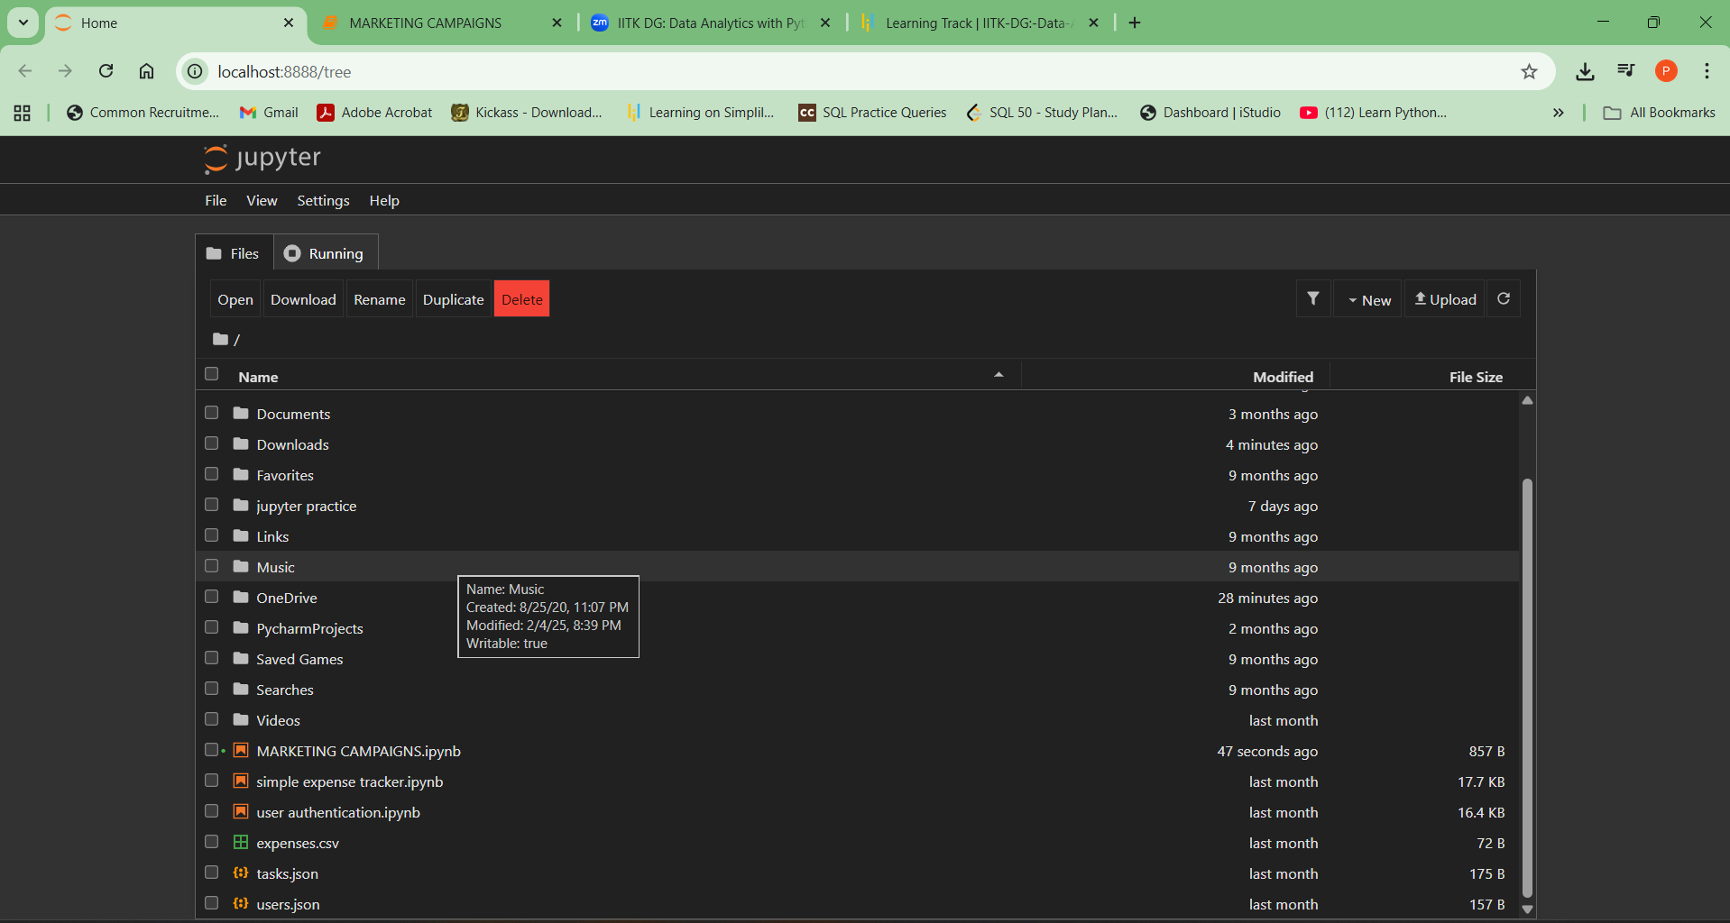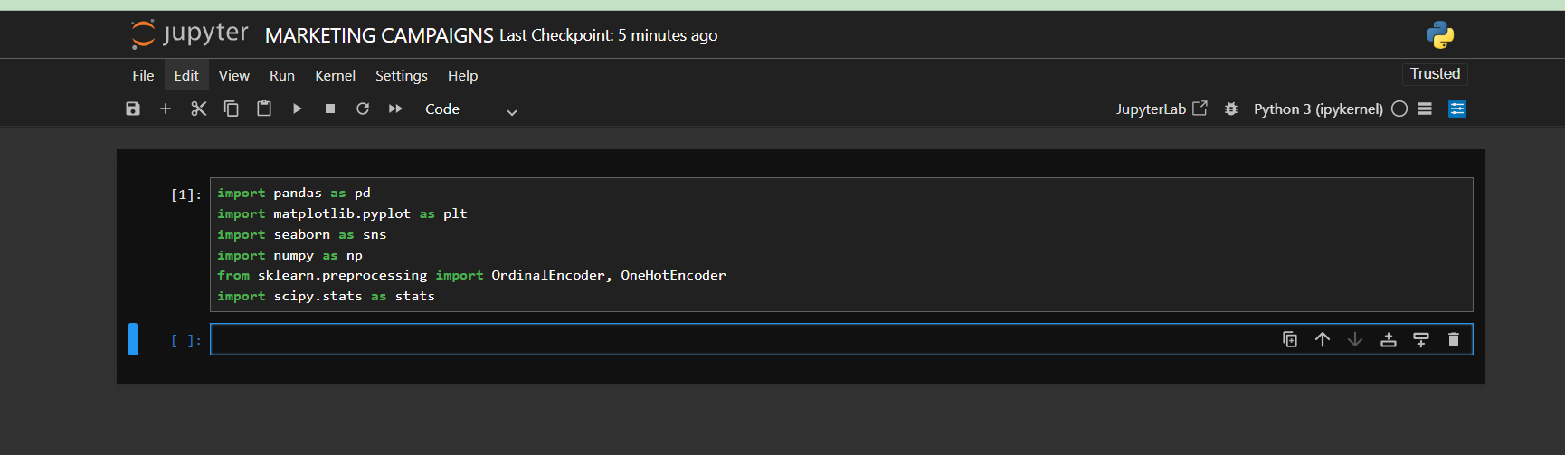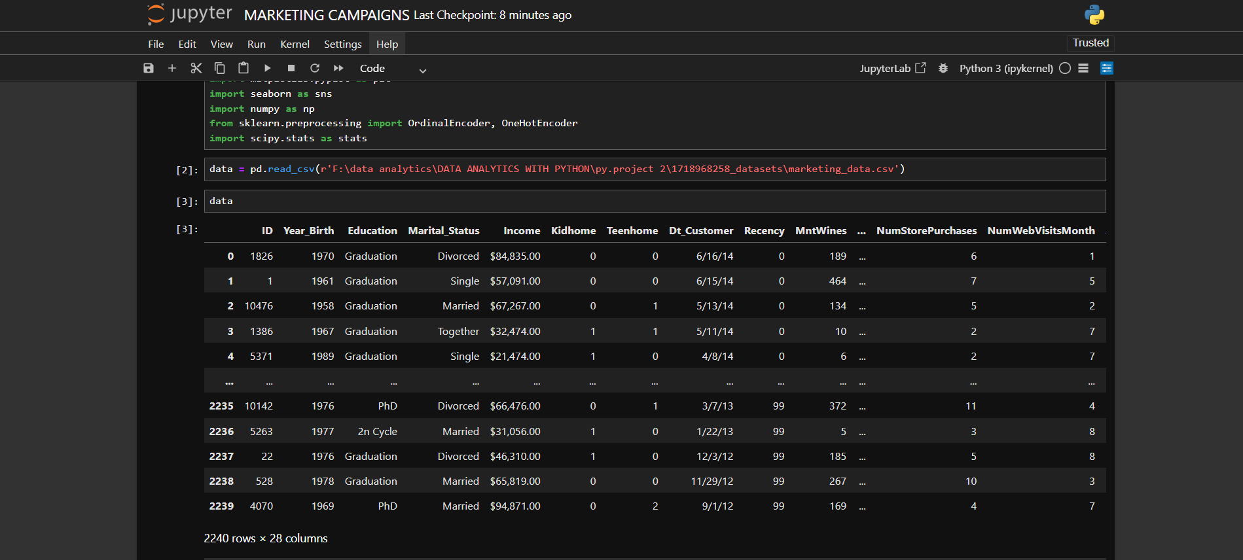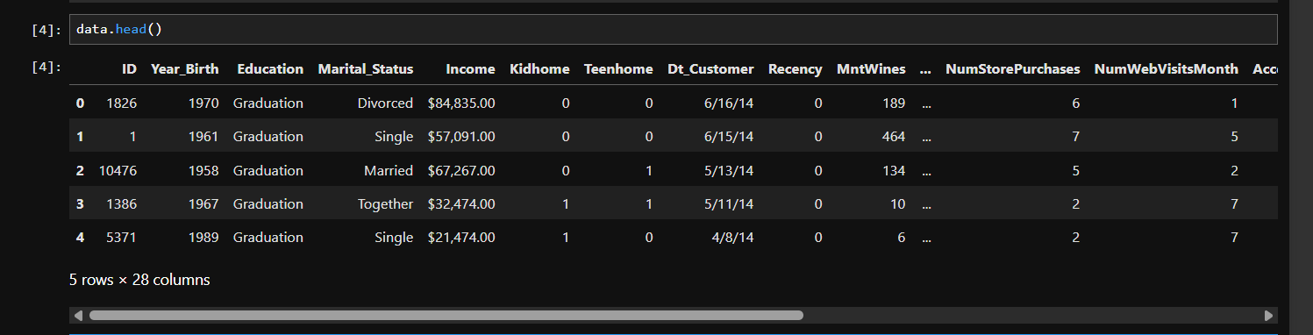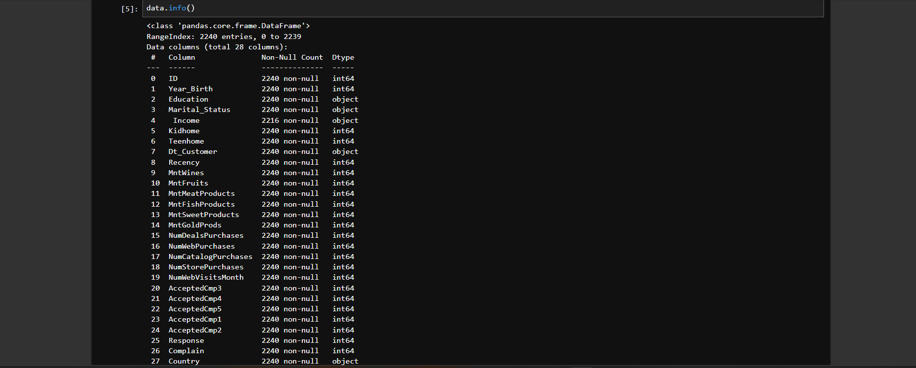

2. Investigate Variables
• Check variables like Dt_Customer and Income to ensure they are imported correctly
• Convert the income column to a float by removing '$' and ',' and using astype('float')
• Convert the Dt_Customer column to a datetime object using pd.to_datetime()
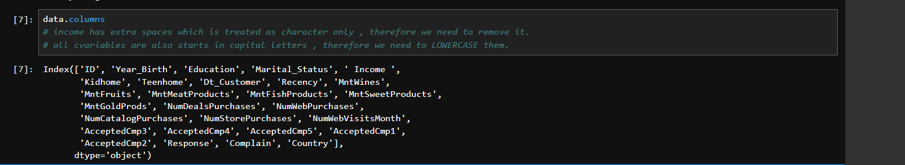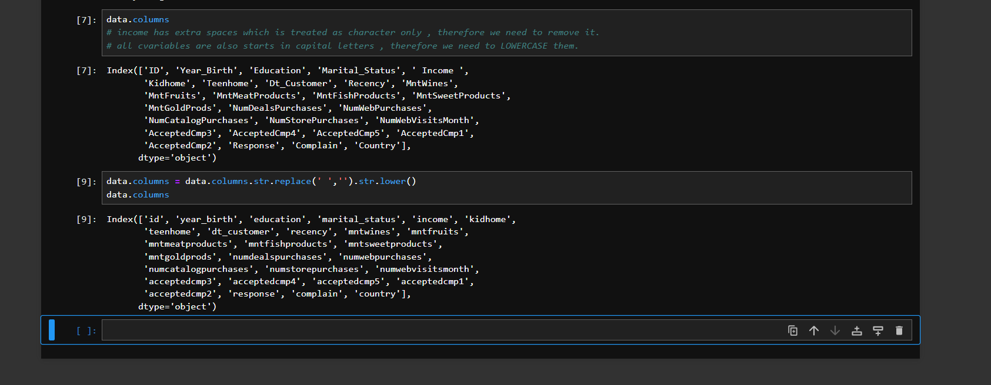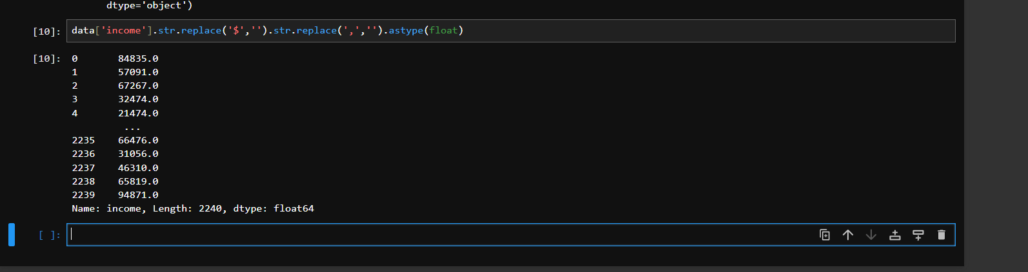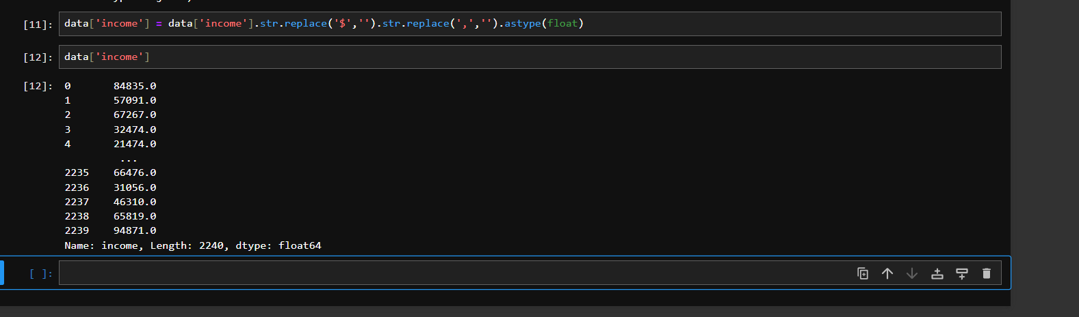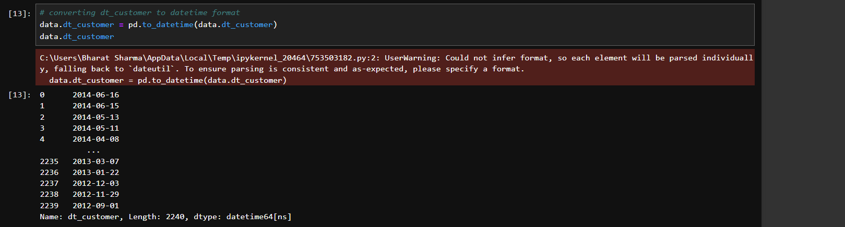
3. Missing Value Imputation
• Check for missing values using data.isnull().sum()
• Clean the marital_status and education categories (e.g., combining similar categories)
• Impute missing income values based on similar education and marital_status categories' average incomes
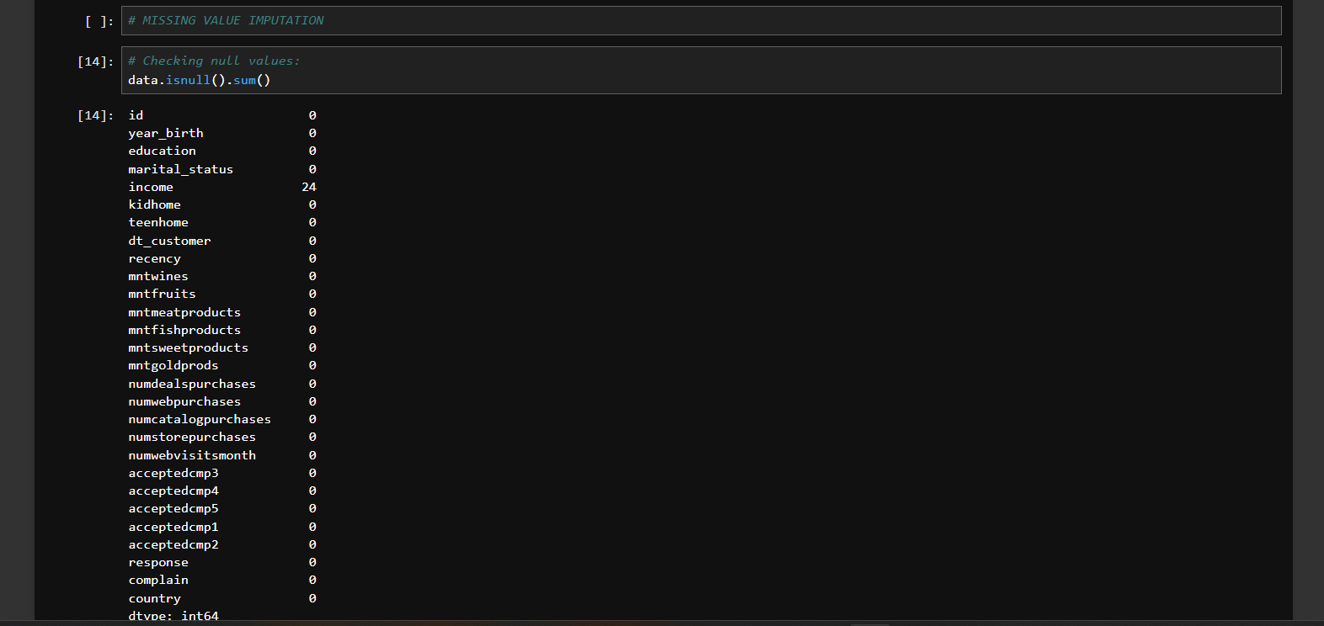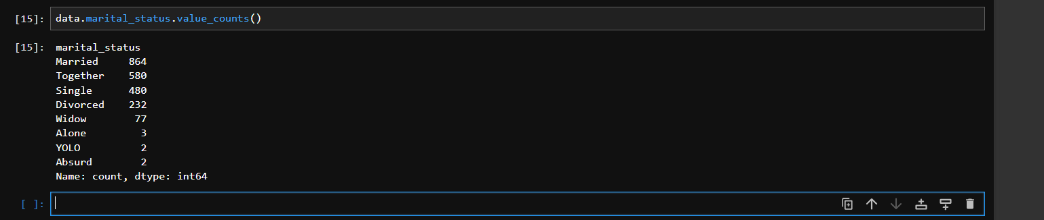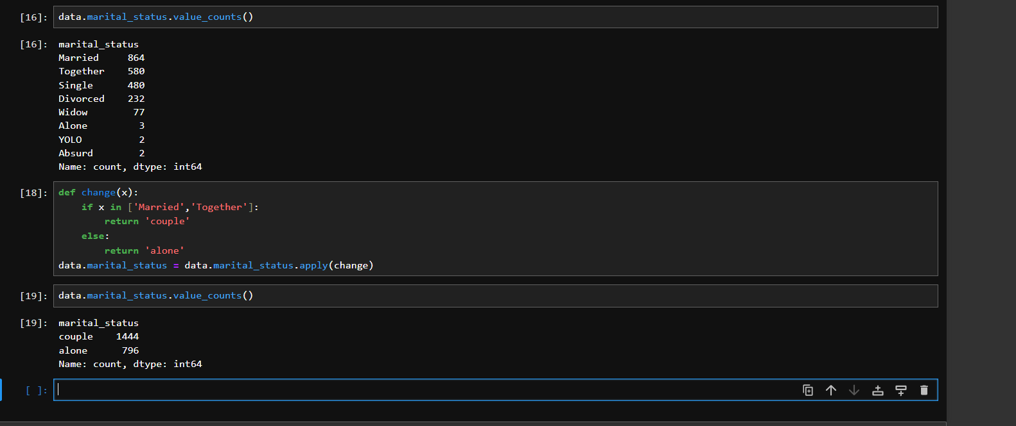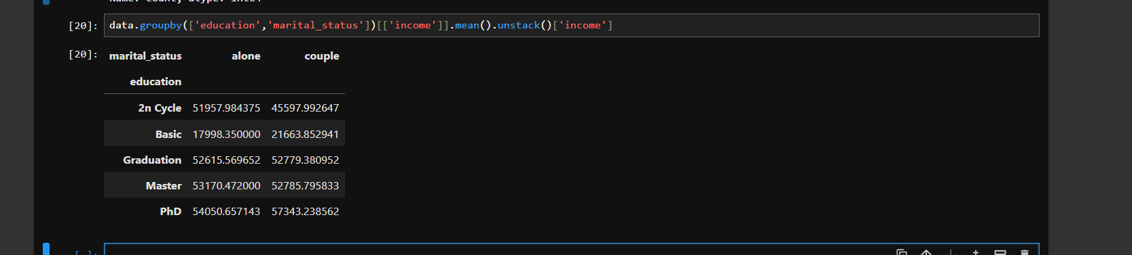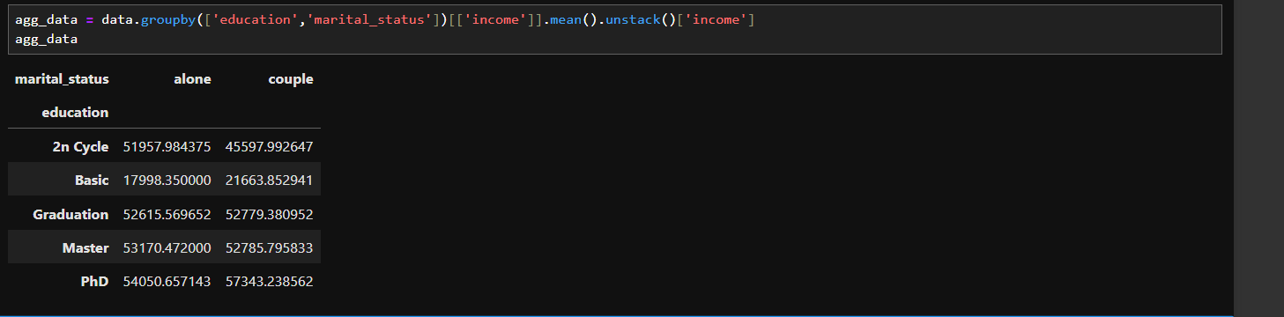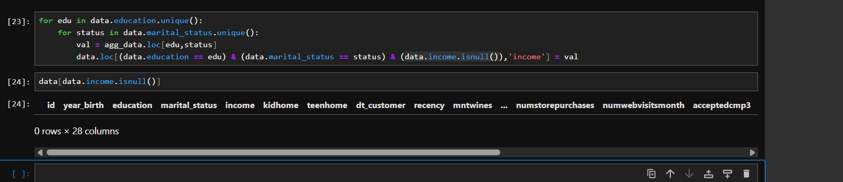

4. Create Variables
• Calculate the age of customers based on year_birth
• Calculate spending as the sum of spending columns (mntwines, mntfruits, etc.)
• Calculate children_count as the sum of kidhome and teenhome.
• Create a binary variable has_children indicating if a customer has children
• Derive total_purchases from the sum of purchase columns

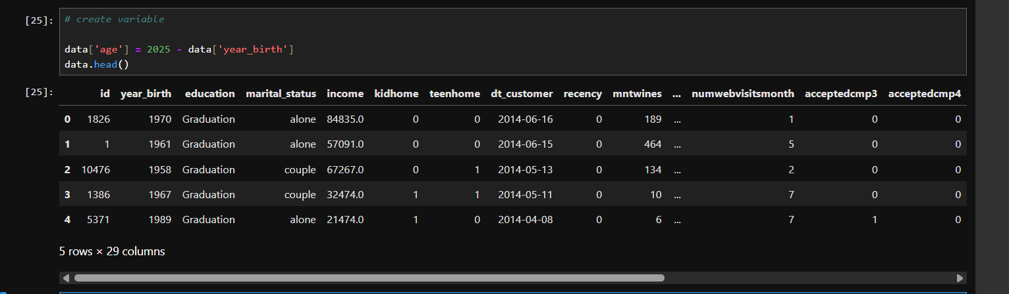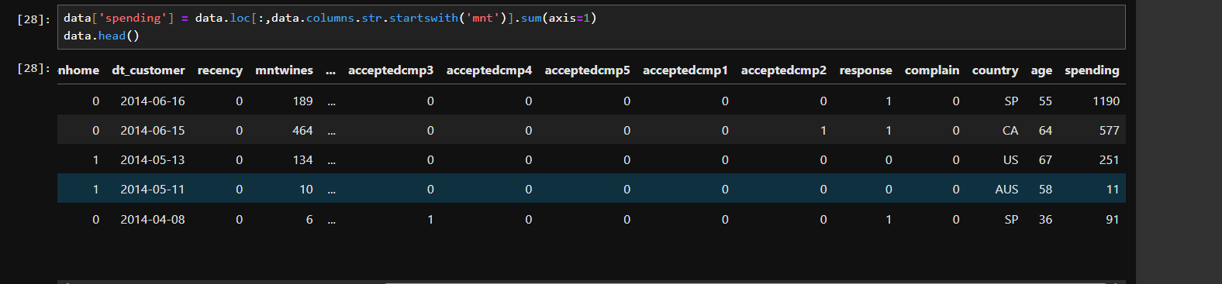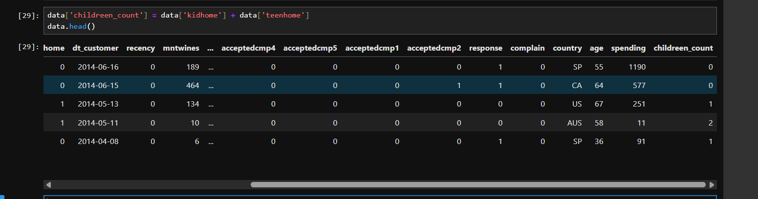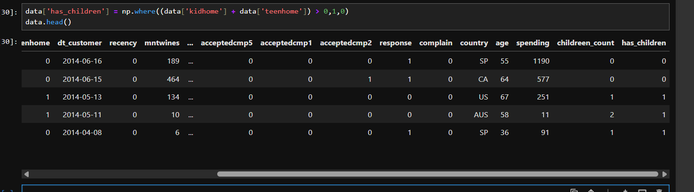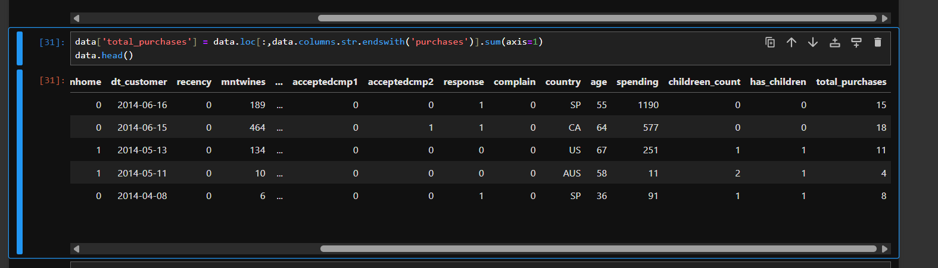

5. Box Plots and Histograms
• Plot box plots and histograms for numerical variables (income, spending, age, total_purchases) to understand their distributions and identify outliers
• Perform outlier treatment by capping the outliers to the upper and lower limits
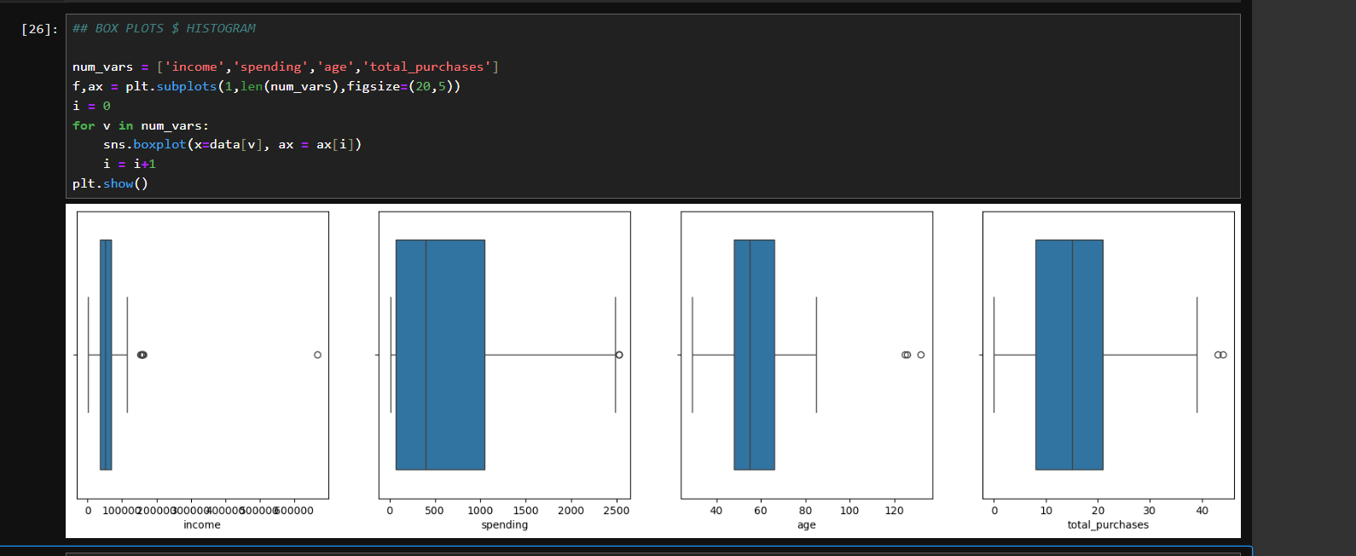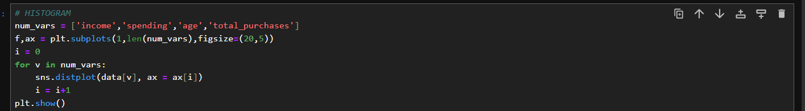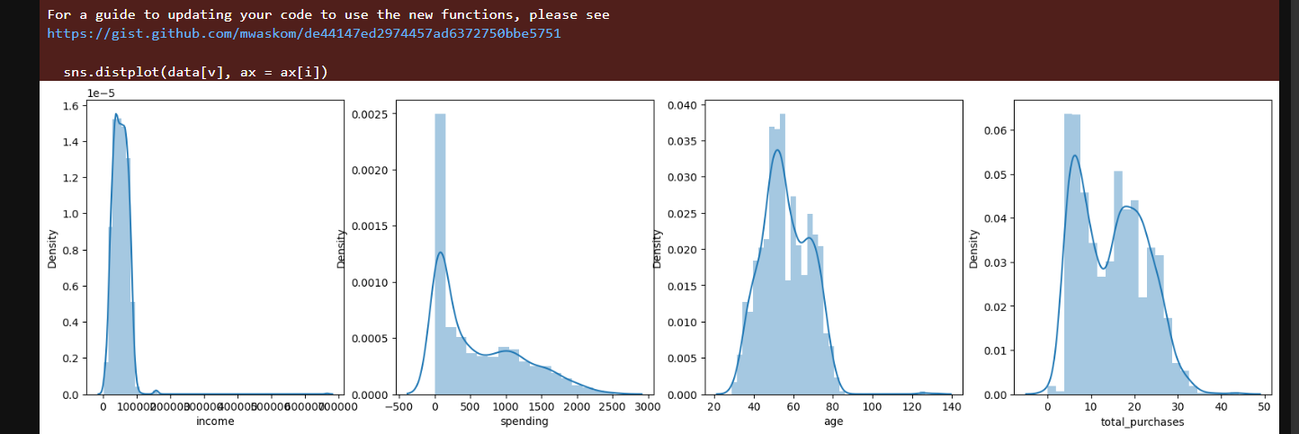

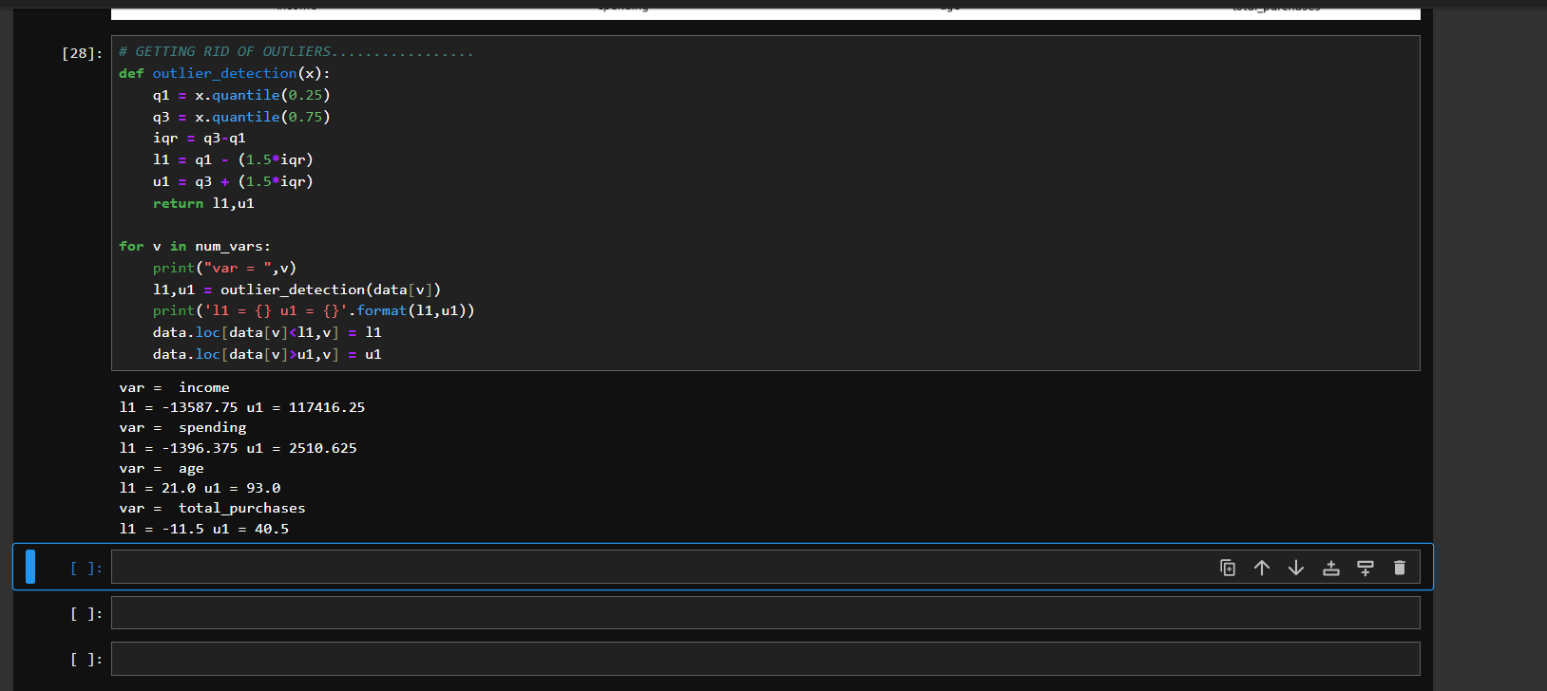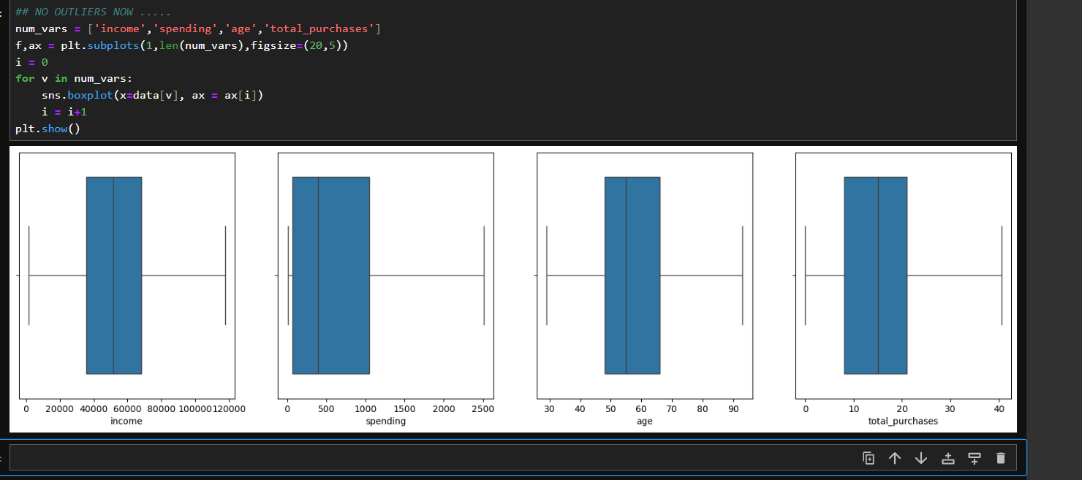
6. Encoding
• Use ordinal encoding for the education column
• Use one-hot encoding for the country and marital_status columns
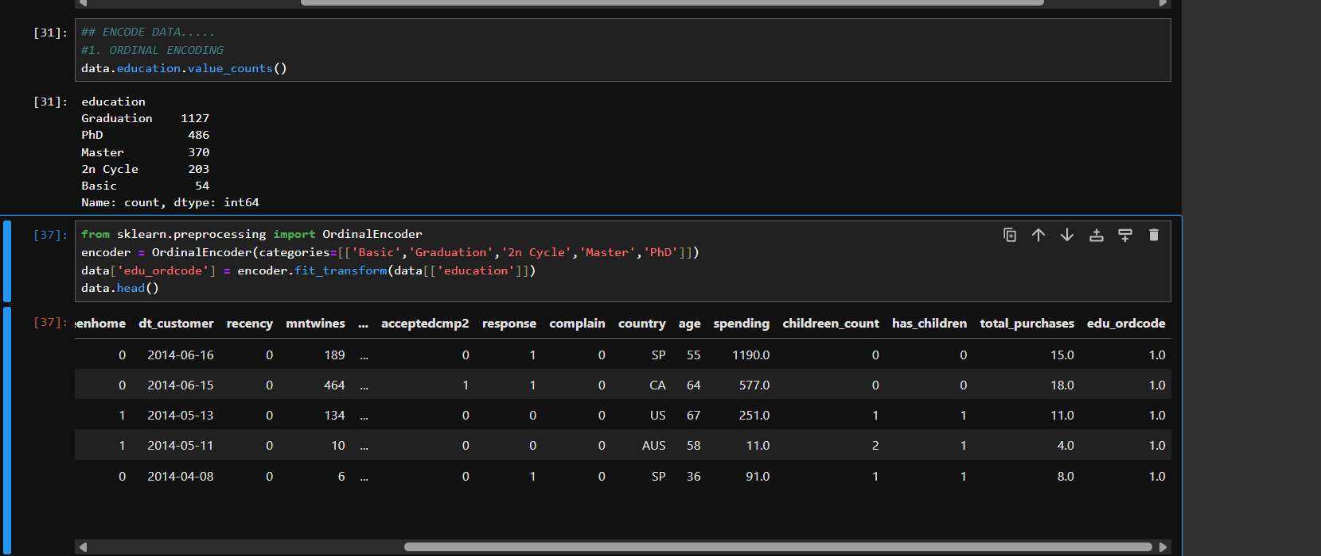
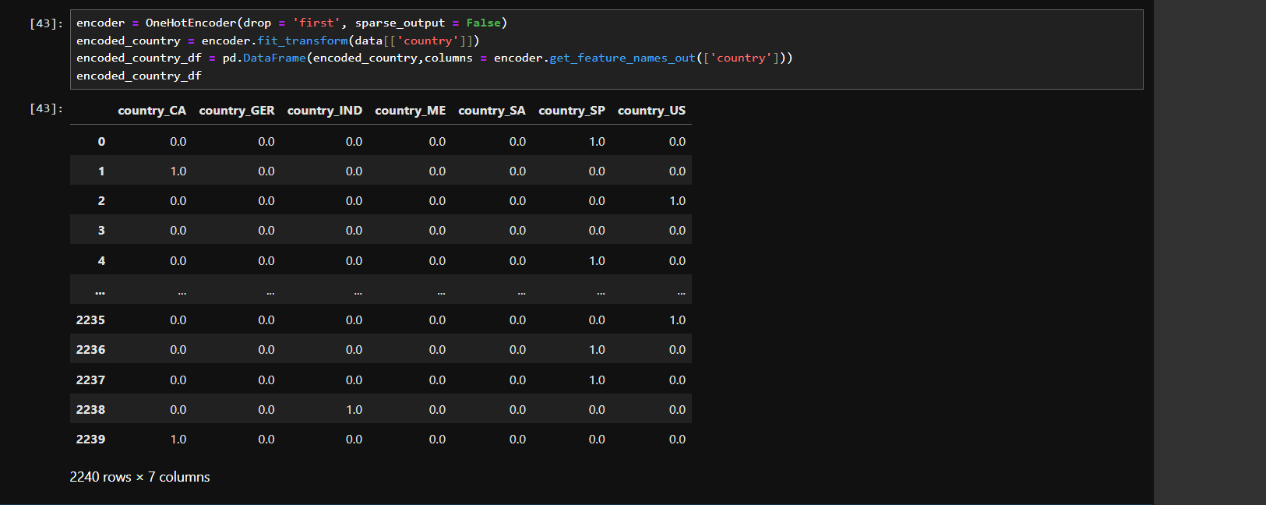

7. Correlation Analysis
• Select a subset of columns for correlation analysis
• Compute the correlation matrix (new_data[var_cor].corr()) and plot a heatmap (sns.heatmap())

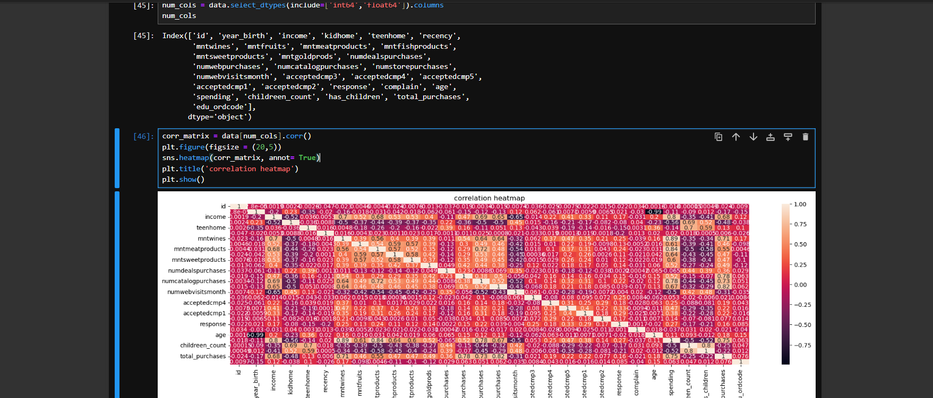

8. Hypothesis Testing
• Define and test hypotheses related to customer behavior using statistical tests (stats.ttest_ind())
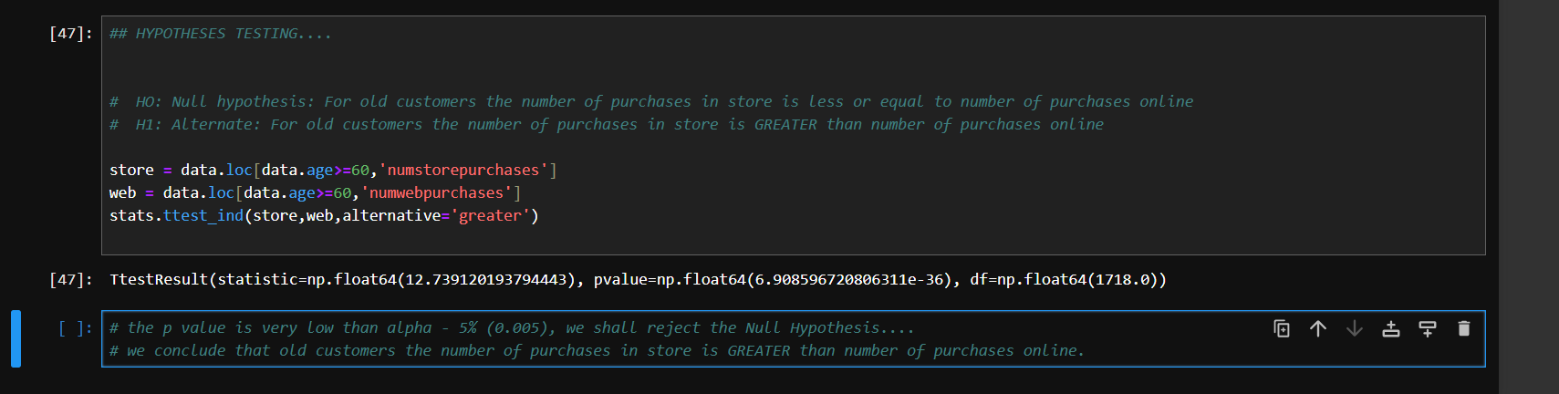
9. Visualization
Visualize the performance of products (prod_data) using a bar plot
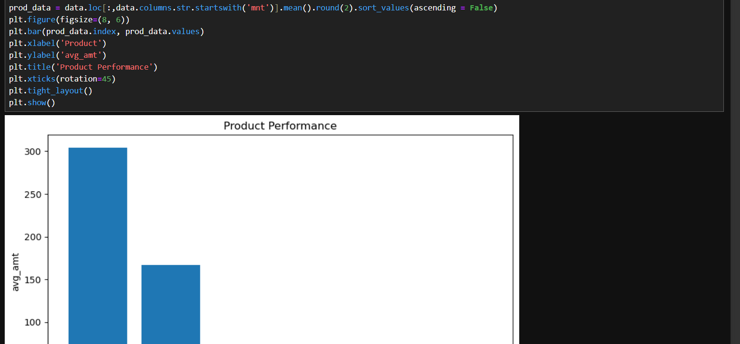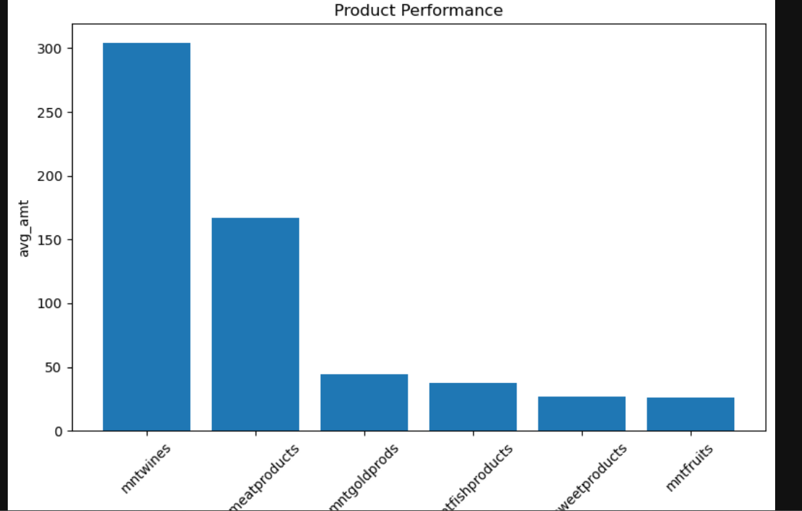
• Explore the relationship between age and campaign acceptance rate (acceptedcmp5) using a bar plot
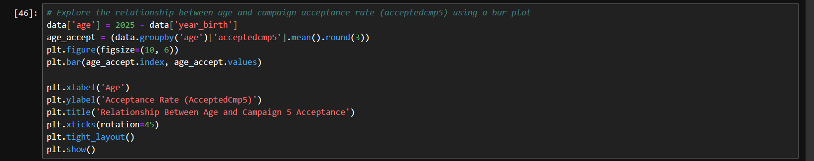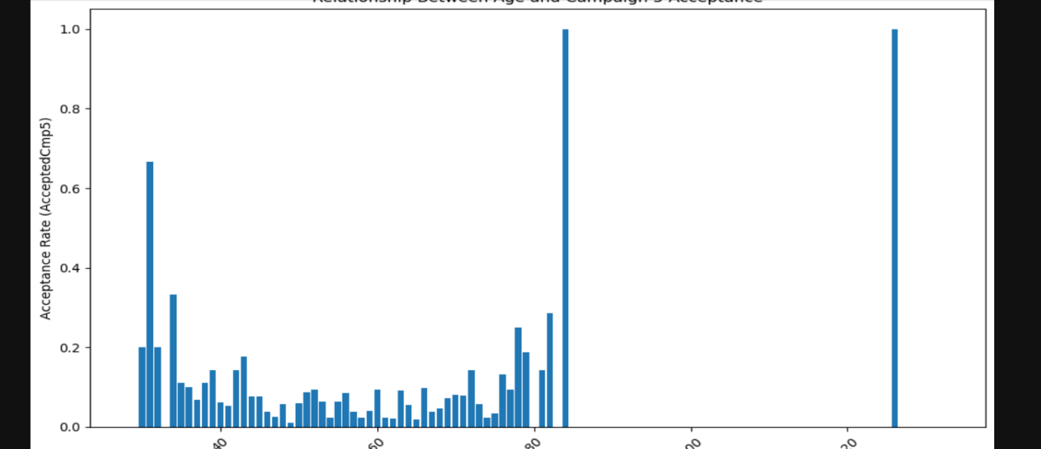

  - * Determine the country with the most customers who accepted the last campaign using a bar plot
  - 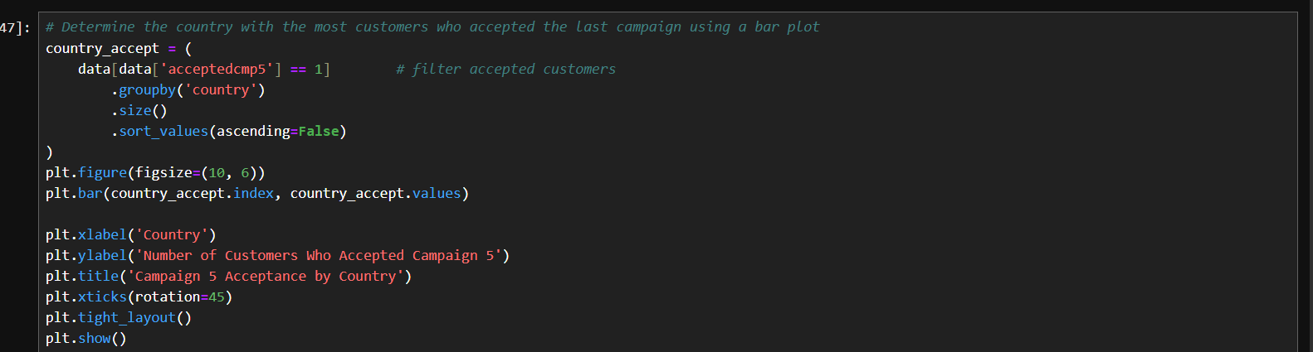
  - 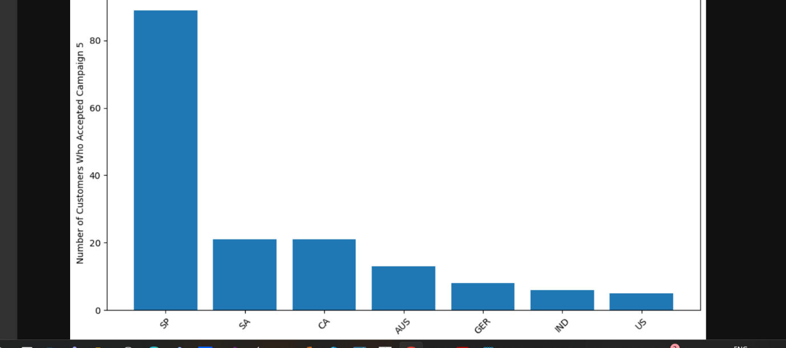

  - * Analyze the relationship between children_count and spending using a strip plot

  - 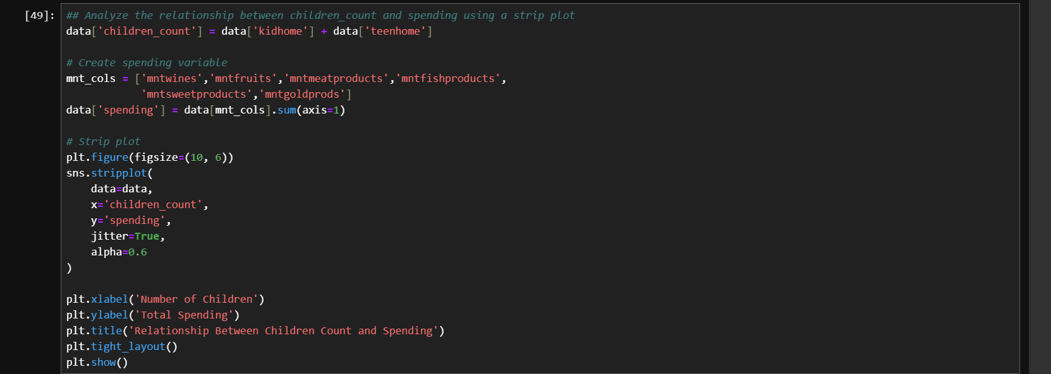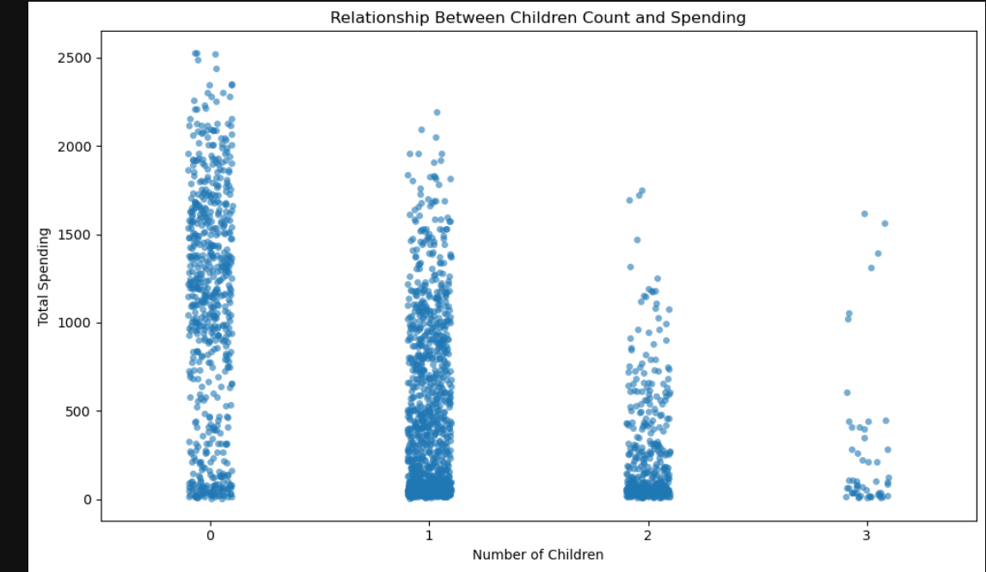

  - * Visualize the educational background of customers who complained in the last two years using a bar plot

  - 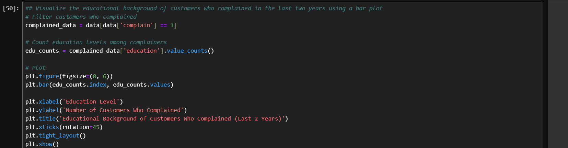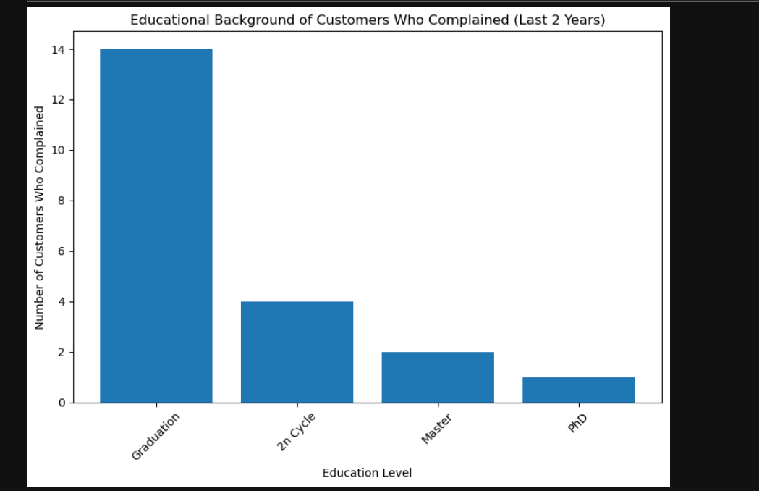

  - * Explore the relationship between income and spending using a scatter plot

